SLUber User Guide

Updated 5/11/18

**Dispatcher**

The dispatcher side of the application allows you to manually add rides from the main phone line, as well as view ones entered from the mobile site. You may also edit rides, mark them as dispatched, picked up, or completed. This will be fully discussed later on.

When you first access the application, you will need to log in. As of this writing, login functionality is not active, so simply clicking the ‘Login’ button will take you to the main screen.

After, you will be directed to the main screen, where you will be presented with the list of all rides in the queue. These rides are refreshed approximately every second with new rides from the mobile site.

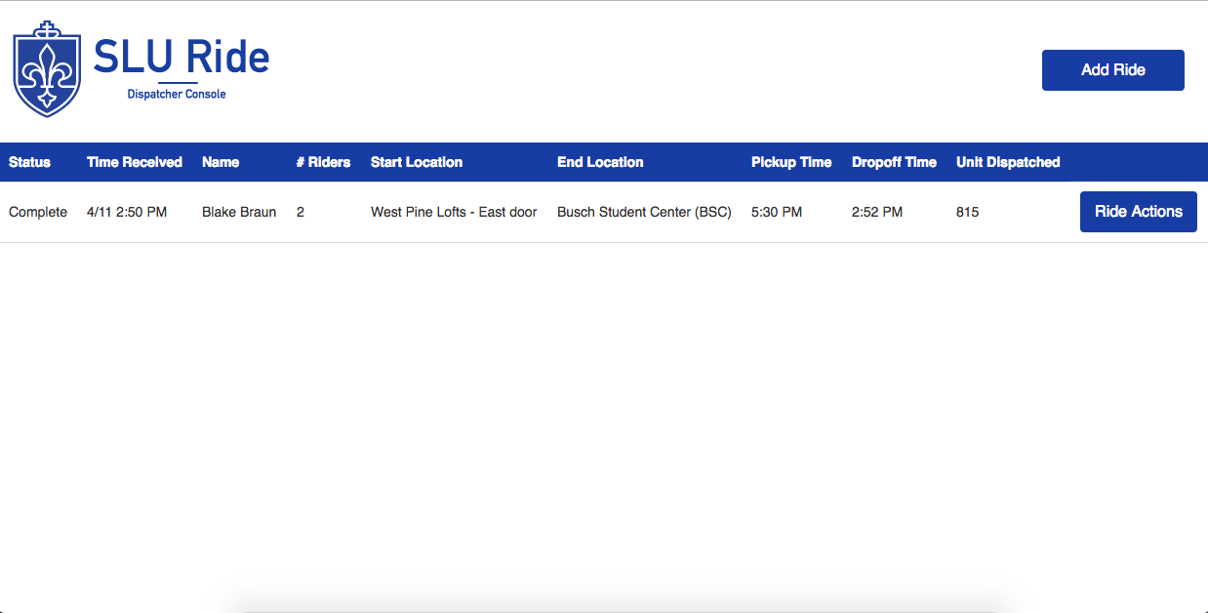

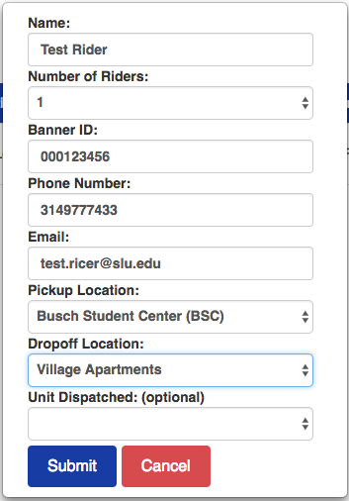

Adding a New Ride

1. Click the ‘Add Ride’ button in the top right corner of the screen.
2. A box will pop up asking for full details. All fields are required except the unit (which can be automatically marked if you’d like to dispatch it immediately)
3. Click the ‘Submit’ button when finished. The page will refresh and your new ride will appear at the bottom of the queue.

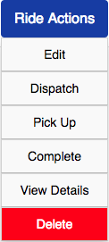

**Ride Actions**

Once a ride is dispatched, there are several actions that you can take. Hover your mouse over the ‘Ride Actions’ button to see the actions available for each ride.

Edit

When you click the ‘Edit’ button, the text for the ride will change to either a dropdown menu or a text field, allowing you to edit the various available fields. This feature will soon be implemented in the information box, allowing you to edit all fields rather than just the primary ones on the main screen. When finished, click ‘Update’. The page will refresh, and your updates will display. If you make a mistake, you may click ‘Cancel’ and your updates won’t be saved, and the ride will return to its normal state of showing only the information in text format. Note that users who have requested their ride on a mobile site may also edit or delete it themselves.

Dispatch

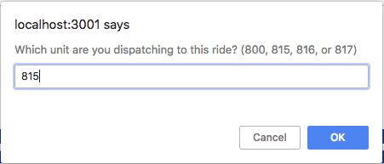When you click the ‘Dispatch’ button, you will receive a popup box asking for a unit number. You will only be able to type in 800, 815, 816, or 817. If you’d like to cancel this without making changes, simply click ‘Cancel’. When you click OK, the ride status will change to ‘Dispatched’ on the far left. The unit will also appear associated with the ride. The user will receive a message listed on their phone stating that the ride is on its way, and to wait outside at their pickup location. They will also not be able to make any further updates to their ride or delete it. Note that only users who have requested a ride using the mobile site will be able to see this message.

Pick Up

After clicking the ‘Pick Up’ button, the ride’s status is marked as ‘In Progress’. A pickup time is attached to the ride for use in calculating response times. The user will receive a message on their phone stating that the ride is currently in progress.

Complete

After clicking the ‘Complete’ button, the ride’s status is marked as ‘Complete’. A dropoff time is then attached to the ride. The user will receive a message stating that the ride has been completed.

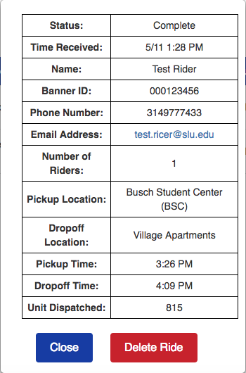View Details

A box will pop up giving full information about each ride, including the rider’s name, banner ID, phone number, pickup/dropoff locations, and more. The ride may also be deleted using this box.

Delete

**This will permanently delete the ride from the database!** For rides that are finished, mark them as complete. Do not delete them! Leaving them in the database allows for future viewing. Deleting rides should be left only for when a ride has been requested but is no longer desired by the user. You will receive a prompt before actually deleting that you may cancel out of.

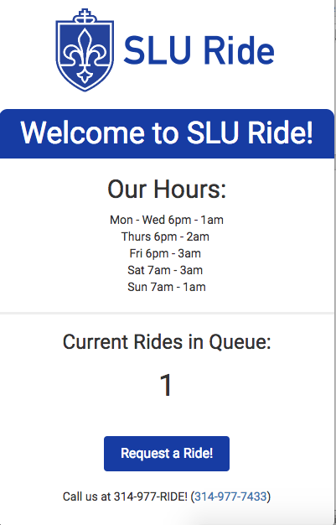**Client**

Upon loading the homepage, you will be greeted with several useful pieces of information. Current SLU Ride hours will be presented to you. The number of rides in the queue is listed (though right now it only shows the total number of rides, not the number of active ones.) A button to request a ride is shown (though eventually won’t be shown outside of SLU Ride’s operating hours.) Lastly, SLU Ride’s phone number is at the bottom, and is clickable to call directly from the user’s device.

Requesting A Ride

Click the ‘Request a Ride!’ button. You will then be prompted for your name, banner ID, phone number, email address, number of riders, and pickup and dropoff locations. All fields are required. The Banner ID must be in the format 00xxxxxxx, the phone number must be in the format xxxxxxxxxx, and the email address must be in the format [abc@xyz.com](mailto:abc@xyz.com). The ‘Use My Location’ button works, but will not work on an actual device, as SSL (https) is required to use a user’s location in the app, which we do not have. The button will automatically change the pickup location to the user’s nearest location on SLU’s campus, and pinpoint it on the Google Map. Future implementation will allow the user to choose the pickup location on the map and have it update the dropdown, and when choosing in the dropdown, it’ll show the selection on the map as well. Clicking the Submit button will bring the user to the completed ride page.

Tracking Ride Status

The user will automatically be directed to a screen stating that the ride is waiting to be dispatched and showing the number of rides in front of them. This number is incorrect, as it just shows the number of rides in the queue minus one. Eventually, this should be fixed. You may edit your ride, such as correcting your phone number or changing your location. This update will push to the dispatcher. You may also delete your ride if you no longer want it. These buttons disappear after the ride has been dispatched. Once the ride is dispatched, you’ll see a message asking you to wait outside at your pickup location. Once it’s picked up and dropped off, you’ll see appropriate updates as well. Right now, there is no way to return to this screen (besides copying the URL or using the browser’s back button or history feature) but this is a possible future feature. This screen refreshes content approximately every second.